how to construct a
Minimal Theory of Mind
s.butterfill@warwick.ac.uk

1. Background: Davidson’s Problem
“We are stuck with our two main ways of describing and explaining things, one which treats objects and events as mindless, and the other which treats objects and events as having propositional attitudes. I see no way of bridging the gap by introducing an intermediate vocabulary.”¹
“chimpanzees understand … intentions … perception and knowledge … Moreover, they understand how these psychological states work together to produce intentional action.”²³
“our [typical adult humans’] fundamental conception of what it is to know that P is itself an explanatory conception […] we think of S’s knowledge that P as something that can properly be explained by reference to what S has perceived or remembered or proved or ...”
“When infants watch an agent act in a scene, SS1 enables them to attribute … motivational states, which specify the agent's motivation in the scene (e.g. goals, dispositions) and reality-congruent informational states … SS2 extends SS1 and enables infants to attribute to agents reality-incongruent informational states; these include false beliefs”²⁵

2. Abilities vs. cognition
A theory of mind ability is an ability that exists in part because exercising it brings benefits obtaining which depends on exploiting or influencing facts about others’ mental states.
Theory of mind cognition paradigmatically involves ascribing propositional attitudes such as beliefs, desires and intentions to give rationalising causal explanations of action.

3. Theory of mind abilities are widespread
Children in their second year use pointing to provide information to others² in ways that reflect their partners’ ignorance or knowledge³; provide more information to ignorant than knowledgeable partners when making requests⁴; predict actions of agents with false beliefs about the locations of objects; and select different ways of helping others depending on whether their beliefs are true or false⁷
Scrub-jays selectively re-cache their food in ways that prevent competitors from knowing its location⁸
Chimpanzees select routes to approach food which conceal them from a competitor’s view⁹ and retrieve food using strategies that optimise their return given what a dominant competitor has seen.¹⁰

4. Question
What could two-year-olds, scrub-jays and chimpanzees represent that would enable them, within limits, to track others’ propositional attitudes?

5. Representing propositional attitudes is hard
(a) Conceptually demanding:
- Acquisition takes several years
- Tied to the development of executive function and language¹⁵
- Development facilitated by explicit training¹⁶ and siblings
(b) Cognitively demanding:
- Requires attention and working memory in fully competent adults

6. What makes representing propositional attitudes conceptually & cognitively demanding?
It involves abductive reasoning about uncodifiably complex causal interactions among states and events individuated by their propositional contents and normative roles.

7. Pure behaviour reading
Pure behaviour reading = segmenting a stream of bodily movement into chunks and discerning relations among chunks on the basis of statistical patterns and other cues not intentions or goals.
Object-directed Behaviour reading involves motor actions that are object-directed such as grasping an object or placing an object. They are object-directed in the sense that their specification involves an object whose properties control how the action is executed

8. How to construct a minimal theory of mind
An agent’s field = a set of objects related to the agent by proximity, orientation, lighting and other factors.
An agent encounters an object = it is in her field
Goal-directed action = a sequence of object-directed actions, which (1) has an outcome that is an outcome of the whole sequence and not any of its constituents, and (2) occurs in order to bring about this outcome.
Principle 3: one can’t goal-directedly act on an object unless one has encountered it.
Application: the “uninformed” condition of Hare et. al’s 2001 experiment with food hiding.¹⁰
Application: scrub-jays, after being observed caching food by a competitor, will re-cache that food when in private.
An agent registers an object at a location [first approximation =] she most recently encountered the object at that location.
Correct registration the object is at the location it is registered at.
Principle 4: correct registration is a condition of successful action.
Applications: 12-month-olds point to inform depending on their informants’ goals and ignorance³; also the “misinformed” condition of Hare et. al’s 2001;¹⁰ scrub-jays, after being observed caching food by a competitor, re-cache that food.
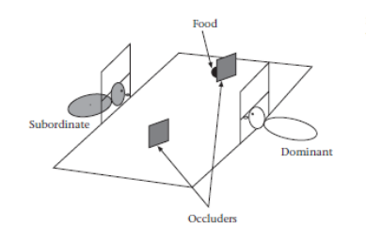 | (Hare, Call and Tomasello 2001: 142, fig. 1)

Principle 5: when an agent performs a goal-directed action and the goal specifies an object, the agent will act as if the object were actually in the location she registers it at.
Applications: false belief tasks⁵⁻⁷

References
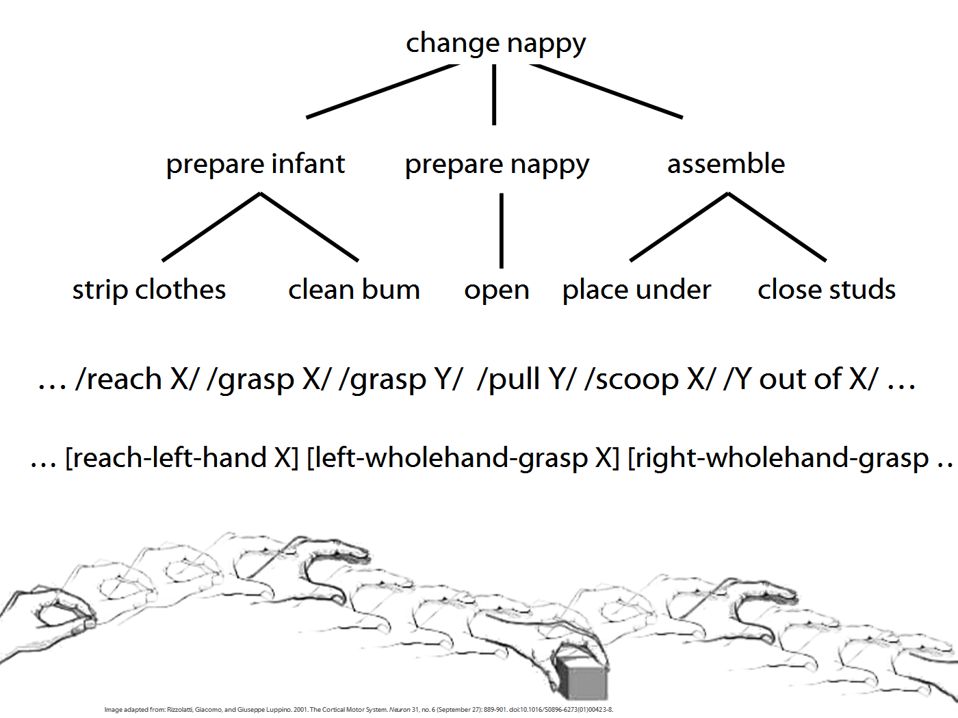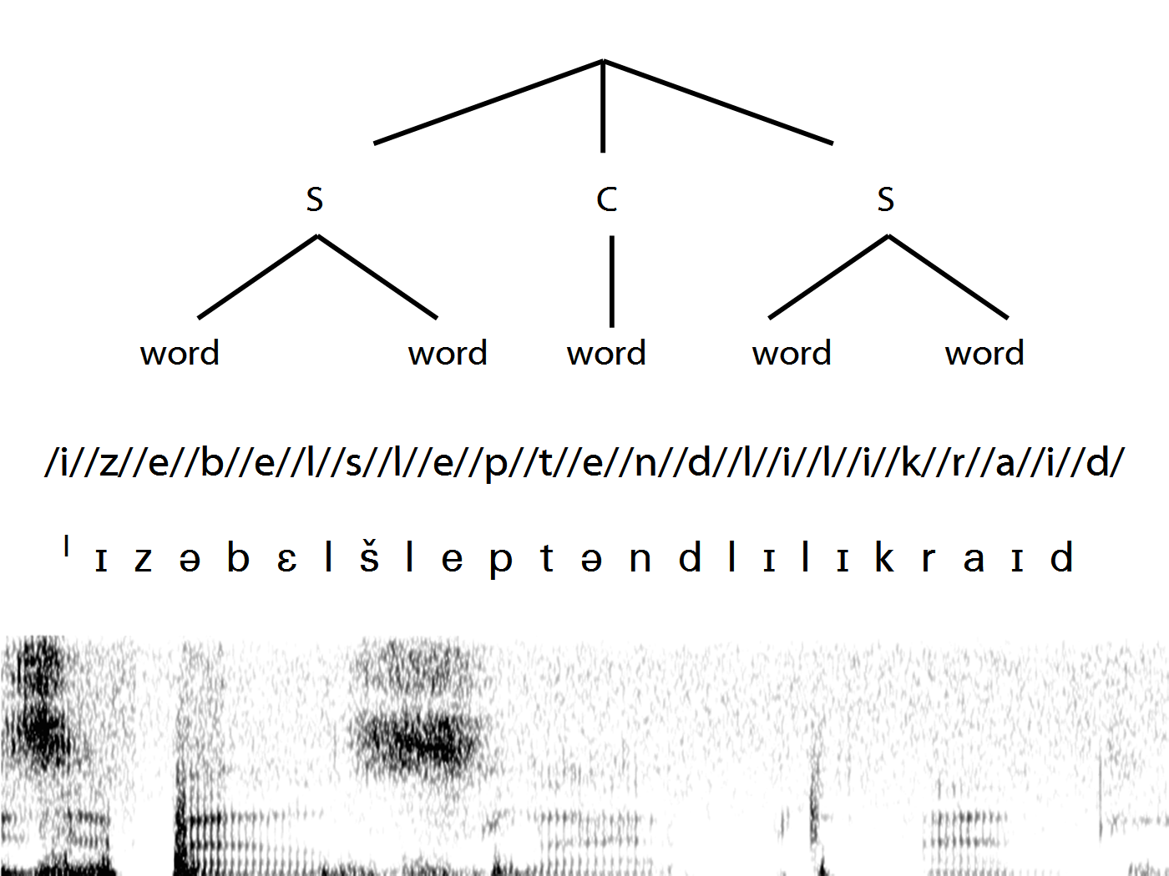
1. Davidson, D. (2003) Responses to Barry Stroud, John McDowell, and Tyler Burge. Philosophy and Phenomenological Research LXVII, 691-699
2. Liszkowski, U., et al. (2006) Twelve- and 18-Month-Olds Point to Provide Information for Others. Journal of Cognition and Development 7, 173-187
3. Liszkowski, U., et al. (2008) Twelve-month-olds communicate helpfully and appropriately for knowledgeable and ignorant partners. Cognition 108, 732-739
4. O'Neill, D.K. (1996) Two-year-old Children's Sensitivity to a Parent's Knowledge State When Making Requests. Child Development 67, 659-677
5. Onishi, K.H., and Baillargeon, R. (2005) Do 15-Month-Old Infants Understand False Beliefs? Science 308, 255-258
6. Southgate, V., et al. (2007) Action Anticipation through Attribution of False Belief by Two-Year-Olds. Psychological Science 18, 587-592
7. Buttelmann, D., et al. (2009) Eighteen-month-old infants show false belief understanding in an active helping paradigm. Cognition 112, 337-342
8. Clayton, N.S., et al. (2007) Social cognition by food-caching corvids. The western scrub-jay as a natural psychologist. Philosophical Transactions of the Royal Society B 362, 507-552
9. Hare, B., et al. (2006) Chimpanzees deceive a human competitor by hiding. Cognition 101, 495-514
10. Hare, B., et al. (2001) Do chimpanzees know what conspecifics know? Animal Behaviour 61, 139-151
11. Wimmer, H., and Perner, J. (1983) Beliefs about beliefs: Representation and constraining function of wrong beliefs in young children's understanding of deception. Cognition 13, 103-128
12. Wellman, H., et al. (2001) Meta-analysis of Theory of Mind Development: The Truth about False-Belief. Child Development 72, 655-684
13. Perner, J., and Lang, B. (1999) Development of theory of mind and executive control. Trends in Cognitive Sciences 3, 337-344
14. Sabbagh, M. (2006) Executive Functioning and Preschoolers' Understanding of False Beliefs, False Photographs, and False Signs. Child Development 77, 1034-1049
15. Astington, J., and Baird, J.A., eds (2005) Why Language Matters for Theory of Mind. Oxford University Press
16. Slaughter, V., and Gopnik, A. (1996) Conceptual Coherence in the Child's Theory of Mind: Training Children to Understand Belief. Child Development 67, 2967-2988
17. Clements, W., et al. (2000) Promoting the transition from implicit to explicit understanding: a training study of false belief. Developmental Science 3, 81-92
18. Hughes, C., and Leekam, S. (2004) What are the Links Between Theory of Mind and Social Relations? Review, Reflections and New Directions for Studies of Typical and Atypical Development. Social Development 13, 590-619
19. Apperly, I.A., et al. (2008) The cost of thinking about false beliefs: Evidence from adults’ performance on a non-inferential theory of mind task. Cognition 106, 1093-1108
20. McKinnon, M.C., and Moscovitch, M. (2007) Domain-general contributions to social reasoning: Theory of mind and deontic reasoning re-explored. Cognition 102, 179-218
21. Davidson, D. (1980) Towards a Unified Theory of Meaning and Action. Grazer Philosophische Studien 11, 1-12
22. Davidson, D. (1990) The Structure and Content of Truth. The Journal of Philosophy 87, 279-328
23. Call, J., and Tomasello, M. (2008) Does the chimpanzee have a theory of mind? 30 years later. Trends in Cognitive Sciences 12, 187-192
24. Cassam, Q. (2007) Ways of Knowing. Proceedings of the Aristotelian Society CVII, 339-358
25. Baillargeon, R., et al. (2010) False-belief understanding in infants. Trends in Cognitive Sciences 14, 110-118
26. Emery, N.J., and Clayton, N.S. (2007) How to Build a Scrub-Jay that Reads Minds. In Origins of the Social Mind: Evolutionary and Developmental Perspectives (Itakura, S., and Fujita, K., eds), Springer

